

**Faculty of Engineering & Technology**

**Electrical and Computer Engineering Department**

**Communication Laboratory - ENEE4113**

**Prelab Exp4 FM Modulation**

**Prepared by:**

Arwa Doha 1190324

**Instructor:**

Dr.Ashraf Al-Rimawi

**Assistant:**

Eng.Mohammed Battat

**Section:** 6

**Date:** Nov 10, 2023

**Software Prelab:**

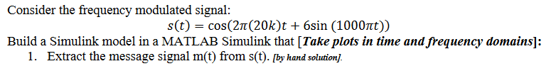



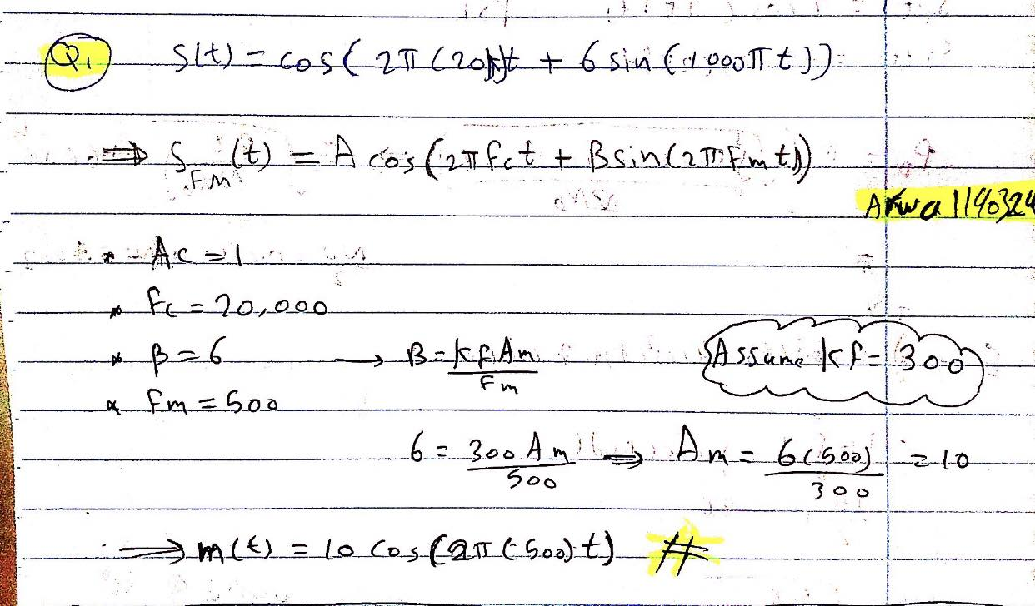

*Fig1: Extract m(t) from s(t) by hand solution.*



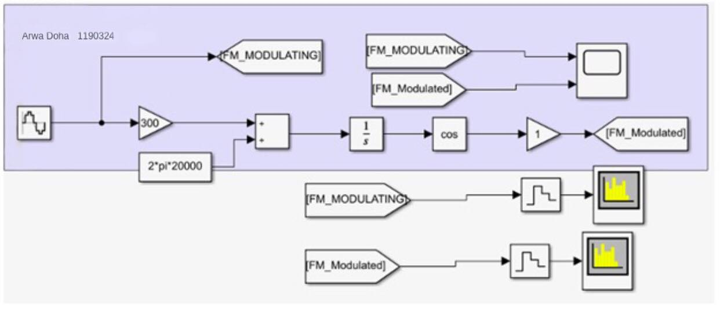

*Fig2: Block diagram of 5 cycle from m(t) and s(t).*

In the time-domain waveform results for message Signal m(t) and Modulated Signal S(t):

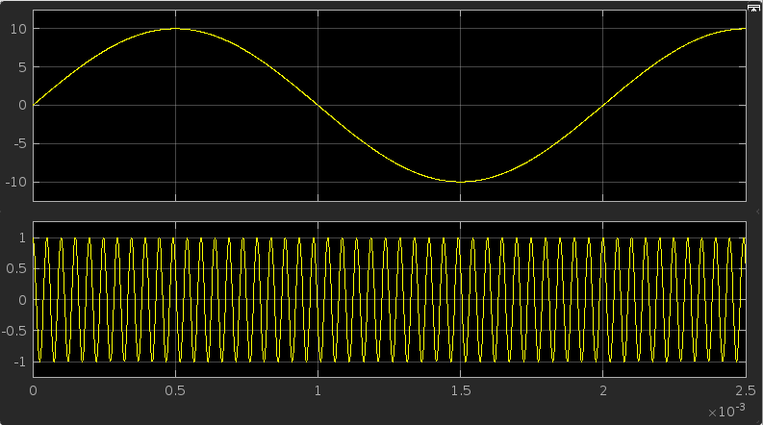

*Fig3: m(t) & s(t) in time domin*

In the freq-domain waveform results for message Signal m(t) and Modulated Signal S(t)

For 5 cycles, but the high frequency of the modulated signal makes it challenging to discern in this representation.:

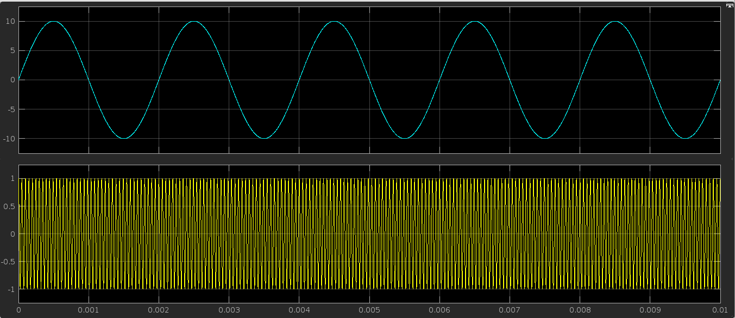

*Fig4: m(t) & s(t) for 5 cycles in time domin*

In the freq-domain waveform results for message Signal: M(F) = 5δ(f-500)+ 5δ(f+500)

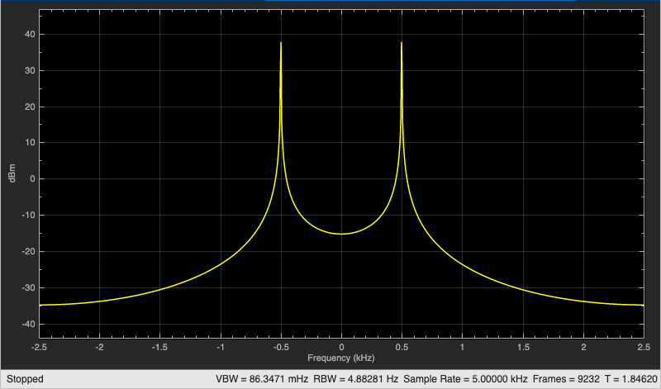

*Fig5: Message Signal m(t) in Frequency Domain*

In the freq-domain waveform for Modulated Signal S(F):

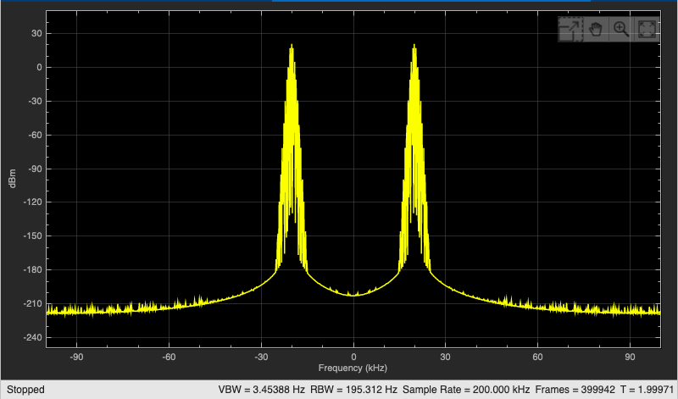

*Fig6: Modulated Signal S(t) in Frequency Domain*

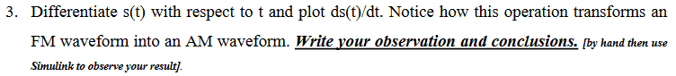

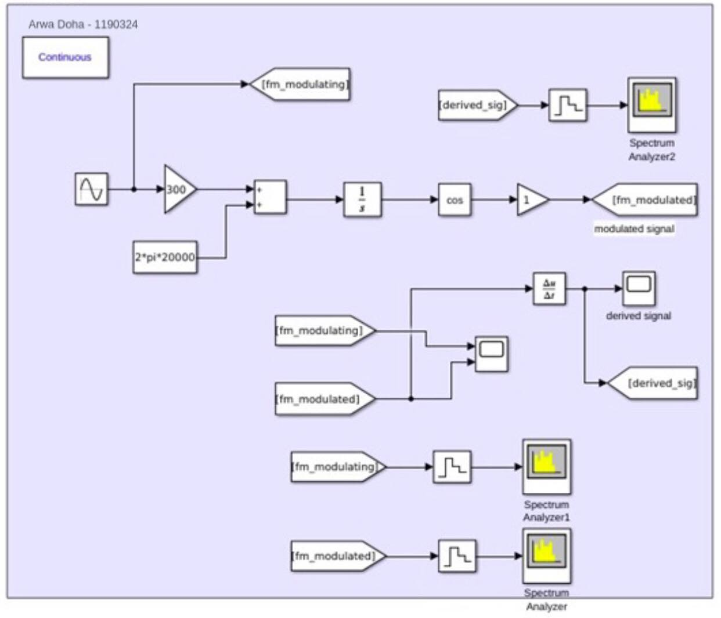

*Fig8: Simulink block diagram of "FM to AM Transformation"*

In the time-domain waveform for derived S(t) modulated signal:

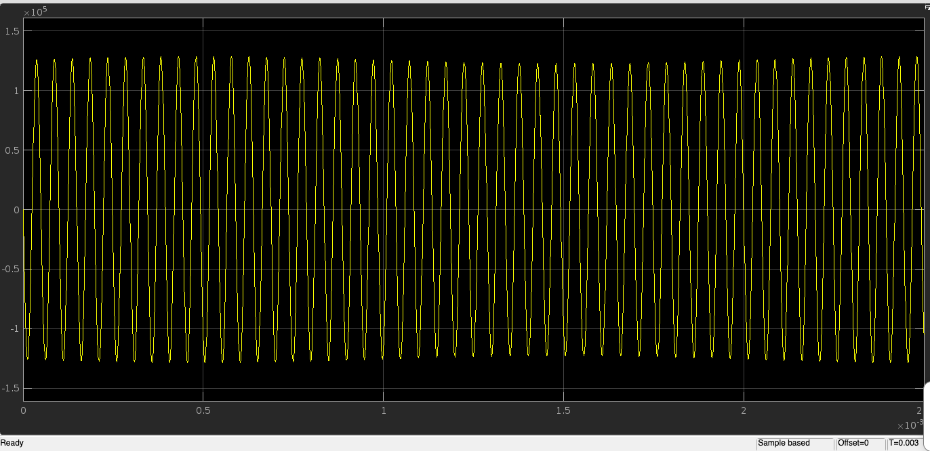

*Fig9: Simulink block diagram in time domain of derived S(t)*

In the frequency-domain waveform for derived S(t) modulated signal:

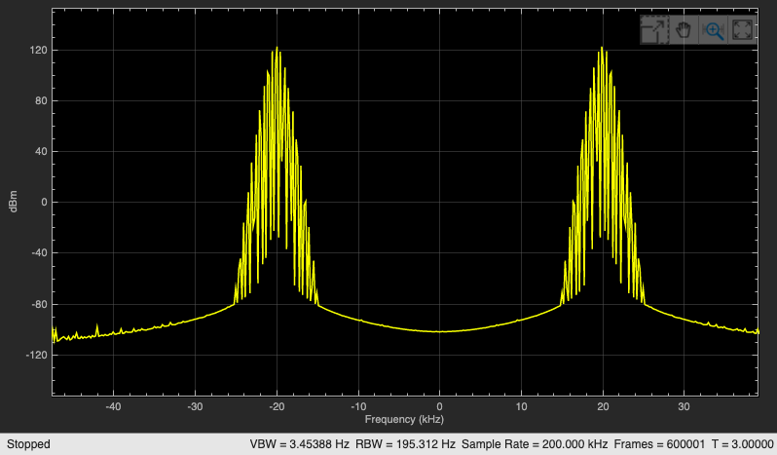

*Fig10: Simulink block diagram in freq domain of derived S(t).*

**Analytical Solution by Hand: Differentiation of S(t)**

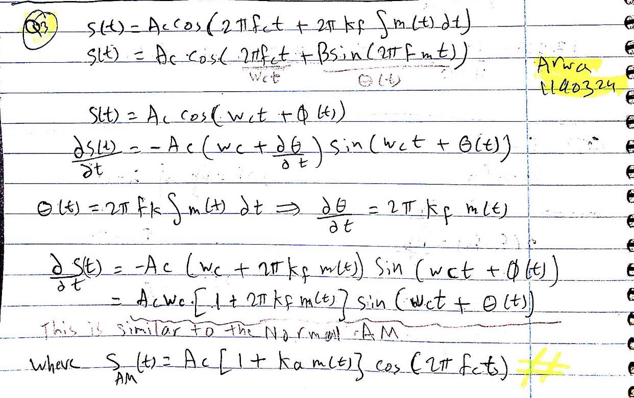

*Fig7: Differentiate s(t) by hand solution*

Observation & Result:

As observed in the waveform, when we differentiate S(t) (FM), we obtain a wave that looks like an AM waveform. As observed in the figures previously, deriving S(t) returns a negative sine wave, but if we overlook the negative sign in the calculations, we have a result =



Inside In this scenario, we multiply the carrier angular frequency (wc) by the carrier amplitude (Ac), and within the parentheses, there is an addition of 1 to a sensitivity constant multiplied by the message signal (m(t)).

The coefficient in this signal closely resembles that of Amplitude Modulation (AM), expressed as Ac [ 1 + Ka*m(t) ] *cos(wct). When the Frequency Modulation (FM) modulation is differentiated with respect to time, it transforms into Amplitude Modulation.



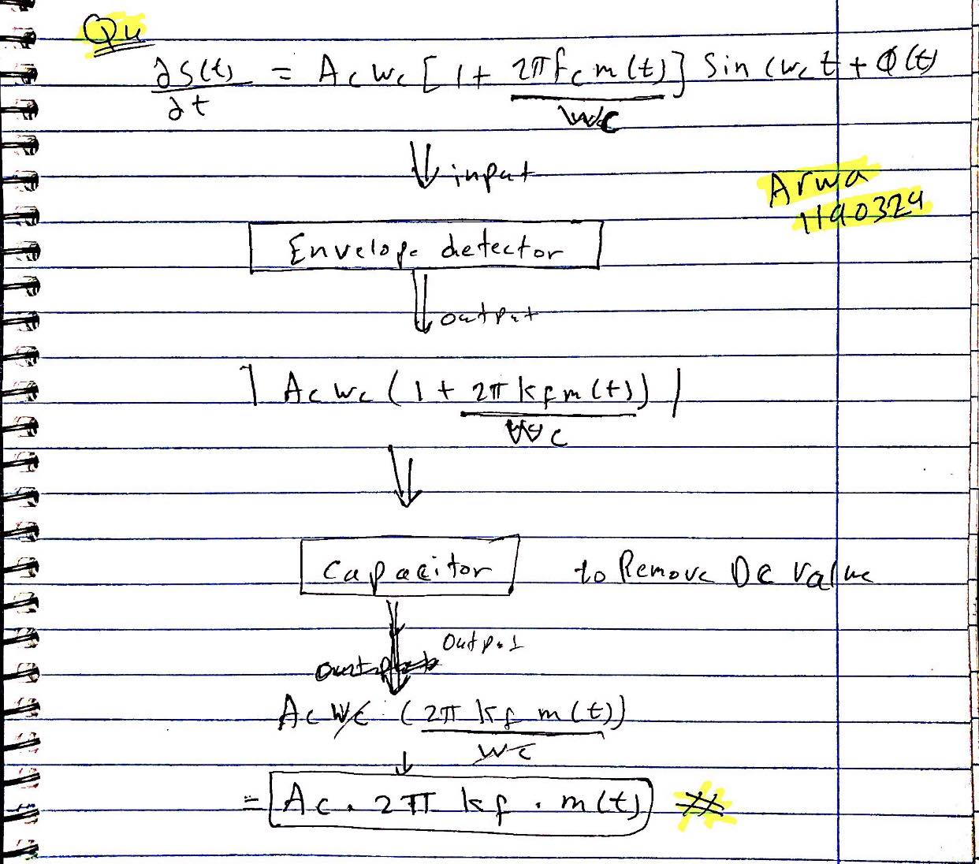

*Fig11: Apply ds(t)/dt to an ideal envelope detector*

Observation & Result:

Applying the derivative of S(t) to an envelope detector yields an output representing the amplitude of the sine function, given by:



When graphed, this results in a cosine wave elevated by the DC value Ac*Wc​. Subsequently passing this signal through a capacitor eliminates the DC component, resulting in an output of [Ac * 2π * kf * m(t) ]

Notably, this output is directly proportional to the message signal, with the amplitude of the message signal multiplied by [Ac * 2π * kf]. Consequently, through this demodulation technique utilizing an envelope detector, the original message signal can be successfully recovered.



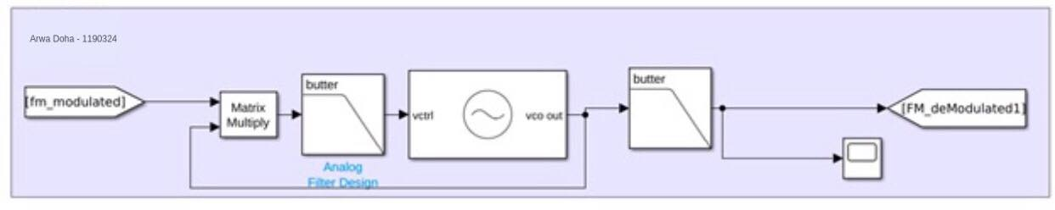

*Fig12: Simulink block diagram of m(t) by using (PLL)*



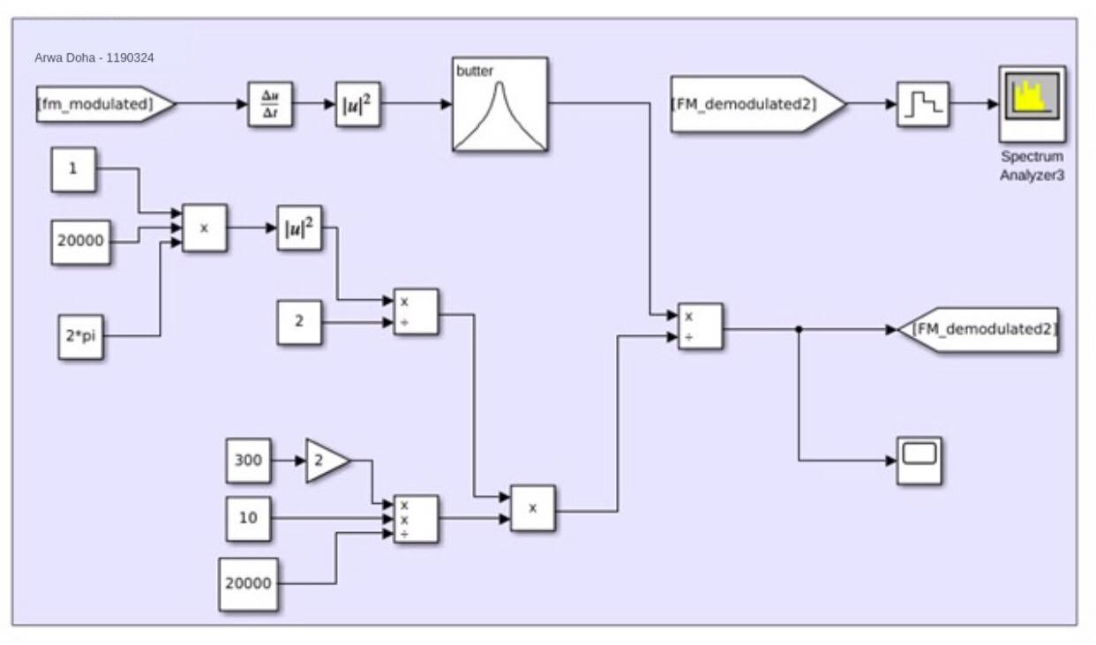

*Fig13: Simulink block diagram of m(t) by envelop detector*

Demodulated Signal in Time Domain (zoomed in when signal is stable)

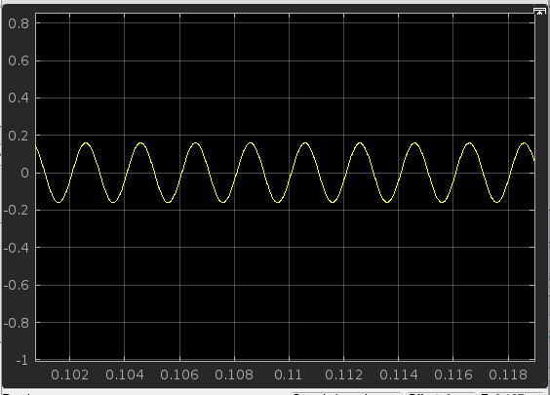

*Fig13: Demodulated Signal in Time Domain*

Demodulated Signal in Frequency Domain (fm=500hz)

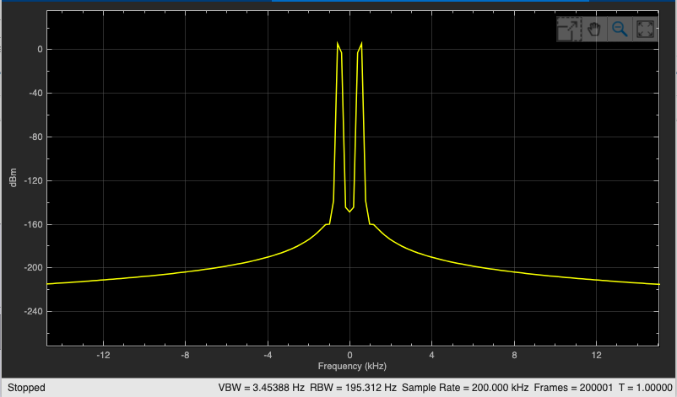

*Fig14: Demodulated Signal in Frequency Domain*.